Mickey Mikkelson, Publicist, Creative Edge
Phone: 403.464.6925
mickey.creativeedge@gmail.com

___________________________________________________________________________________________
HOW TO LIVE LIKE A MONK
MEDIEVAL WISDOM FOR MODERN LIFE

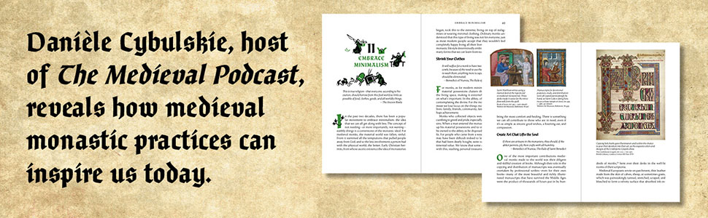

How medieval monastic practices―with their emphasis on a healthy soul, mind, and body―can inspire us to live fuller lives today

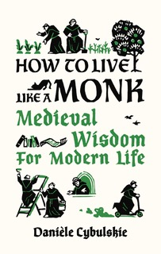
We know that they prayed, sang, and wore long robes, but what was it really like to be a monk? Though monastic living may seem unimaginable to us moderns, it has relevance for today. This book illuminates the day-to-day of medieval European monasticism, showing how you can apply the principles of monastic living, like finding balance and peace, to your life.
With wit and insight, medievalist and podcaster Danièle Cybulskie dives into the history of monasticism in each chapter and then reveals applications for today, such as the benefits of healthy eating, streamlining routines, gardening, and helping others. She shares how monks authentically embraced their spiritual calling, and were also down to earth: they wrote complaints about being cold in the manuscripts they copied, made beer and wine, and even kept bees.

How to Live Like a Monk features original illustrations by Anna Lobanova, as well as more than eighty color reproductions from medieval manuscripts. It is for anyone interested in the Middle Ages and those seeking inspiration for how to live a full life, even when we’re confined to the cloister of our homes.

How to Live Like a Monk: Medieval Wisdom for Modern Life: Cybulskie, Danièle, Lobanova, Anna: 9780789214133: Amazon.com: Books

https://www.amazon.ca/How-Live-Like-Monk-Medieval-ebook/dp/B09JXM1YT7/ref=sr_1_1?crid=WO2G8T337TRM&keywo

This beautifully illustrated self-help guide . . . reimagines monastic practices to help readers live with greater peace, simplicity, and purpose.— Publishers Weekly
Cybulskie relates how people today can. . . find peace, simplicity, and purpose in their lives. . . Though modern-day readers might not want to fully embrace the monastic life, they can benefit from such practices as meditation, making peace with their pasts, and practicing gratitude.
—Library Journal
This is a brilliant concept, beautifully delivered. . . told with great knowledge, with a view to passing on lessons learnt many hundreds of years ago, but still so relevant today. This highly original work is the perfect antidote to the stresses of modern life.— Charles Spencer, historian and best-selling author of Killers of the King and The White Ship

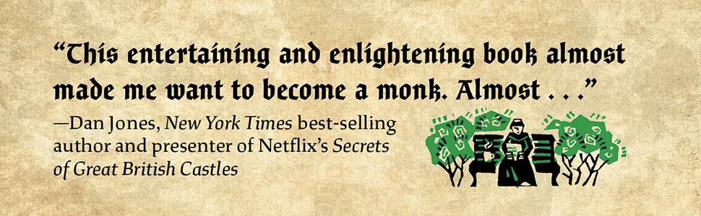

More From Daniėle Cybulskie:
"...well organized and accessibly written [...] a good starting point for students of history who want to examine quotidian life."
Booklist
"An eye opener... Brilliant."
Books Monthly
...an excellent book... It is refreshing to finally see a book that puts to bed all the false impressions and caricature of medieval life as depicted in so much popular media."
Battles and Book Reviews

About Daniėle:
As a writer, TEDx speaker, former college professor, and podcaster, Danièle has made medieval history fun, entertaining, and accessible for millions of people around the world. As well as introducing a general audience to the fascinating world of the Middle Ages, her books, articles, videos, and weekly podcast have been used as resources in schools and universities across North America. Danièle’s mission is to share the joy of history by highlighting our common humanity across time and space. When she’s not reading, writing, or recording, Danièle can be found drinking tea, doing Krav Maga, or sometimes building a backyard trebuchet.

To request additional review copies or an interview with Danièle, please contact Mickey Mikkelson at Creative Edge Publicity: mickey.creativeedge@gmail.com / 403.464.6925.

We look forward to the coverage!

